**Referensi Assest.**

 Designed by photopea

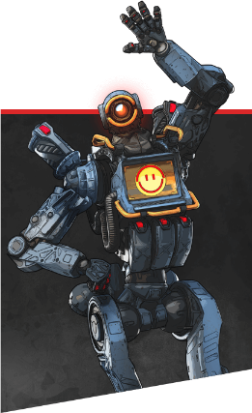

<https://www.pikpng.com/pngvi/ihTmRhm_we-are-here-to-give-best-tips-for-apex-legends-most-pathfinder/>

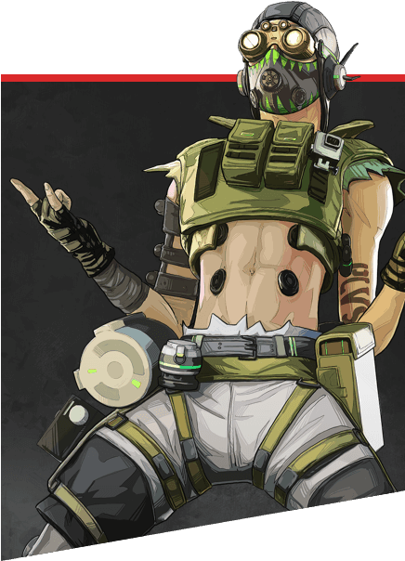

<https://www.pngitem.com/middle/Thhbbxh_octane-apex-legends-png-transparent-png/>

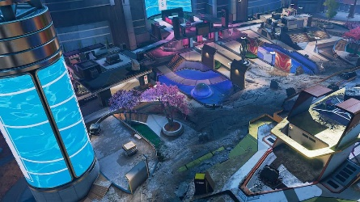

<https://progameguides.com/apex-legends/best-legends-to-play-on-party-crasher-arenas-map-in-apex-legends/>



<https://www.freepnglogos.com/images/email-logo-png-1114.html>

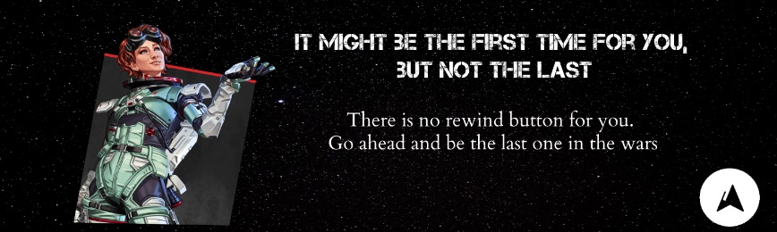 designed with photopea

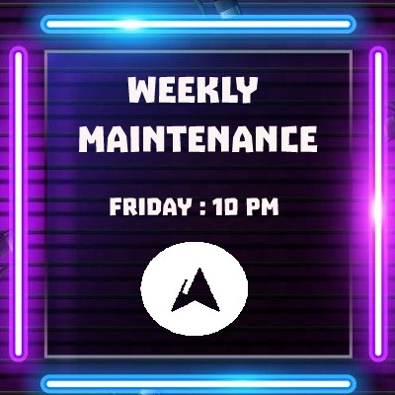

Designed with photopea

Bg : https://in.pinterest.com/pin/789889222129728236/



Bg : <https://www.vectorstock.com/royalty-free-vector/spotlight-against-brick-wall-empty-studio-vector-27209443>

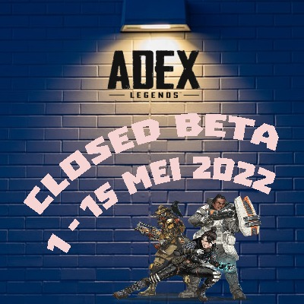

Character : https://www.dlf.pt/ddetail/TRhJRxo_apex-legends-png-apex-legends-characters-png-transparent/

Bg : <https://www.pinterest.com/pin/677439968930881544/>

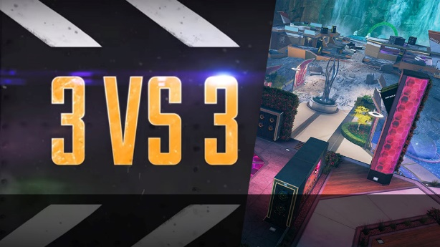

<https://mobillegends.net/apex-legends-dark-depths-event-adds-a-new-arena-map>

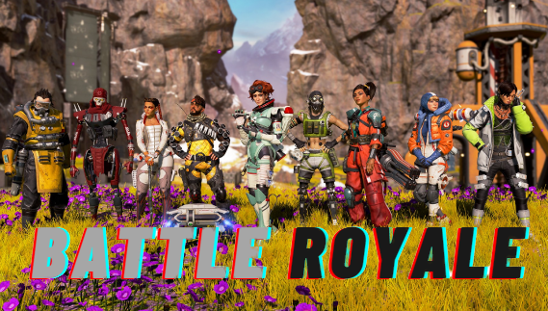

Edited by photopea

Bg : <https://www.touchtapplay.com/6v6-team-death-match-apex-legends-mobile-overview/>



Edited by photopea





<https://www.kindpng.com/imgv/iRTmRTT_crypto-apex-legends-drone-hd-png-download/>

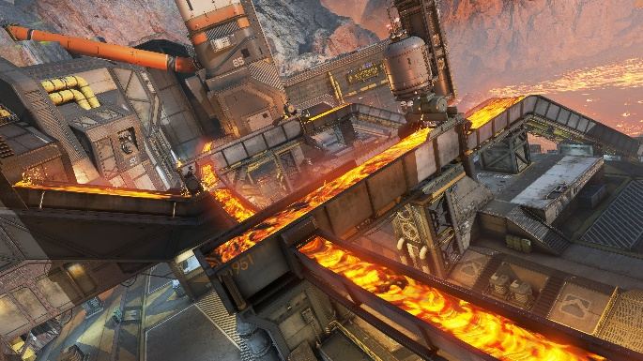 https://www.ea.com/games/apex-legends/maps

 <https://revivaltv.id/news/others/karakter-apex-legends>

 <https://liquipedia.net/apexlegends/Rampart>

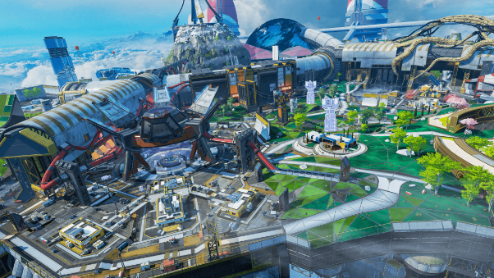 <https://store.playstation.com/ko-kr/product/UP0006-CUSA12540_00-COIN600000000000>

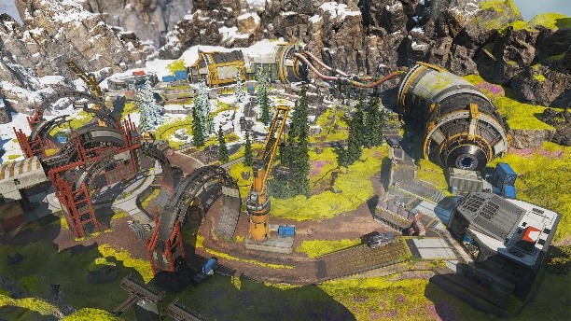 <https://www.slythergames.com/2021/05/18/apex-legends-complete-arena-mode-map-guides/>

 designed by photopea

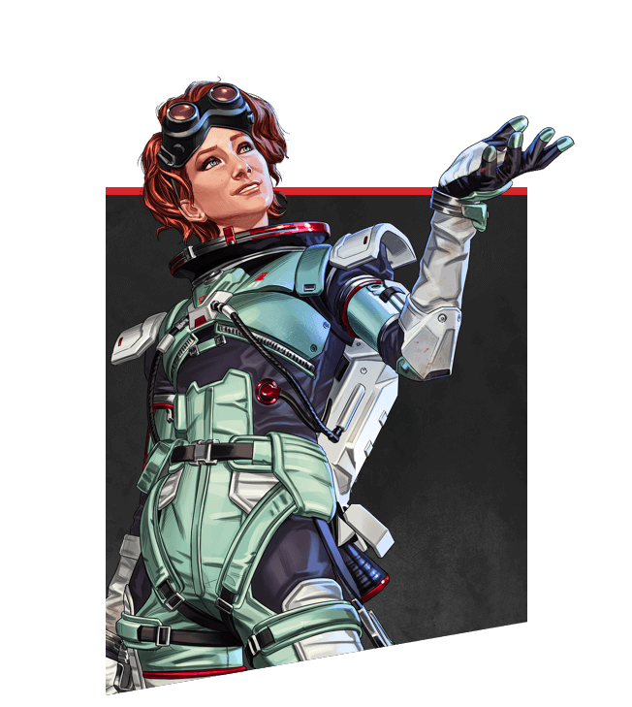 <https://www.ea.com/games/apex-legends/about/characters/horizon>

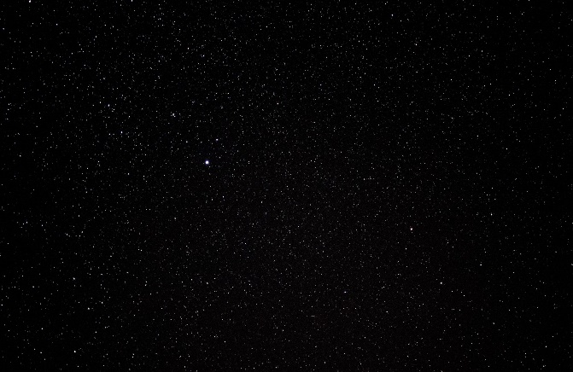 <https://www.rainbowglitterstar.com/>

 <https://www.freepik.com/premium-photo/white-teak-wood-texture-wood-background-background_4098783.htm>

Video game play (about us) di dapatkan dari teman saya melalui whatsapp

Video di homepage di dapatkan dari :

<https://youtu.be/_ZpLbriJXvM> – video sudah di cut

